

**CHURCHLANDS SENIOR HIGH SCHOOL**

**MATHEMATICS SPECIALIST 3, 4 Last Test 2016**

**NON-Calculator Section**

**Chapters 9 to 12**

**Name________________________________ Time: 20 minutes**

**Total: 22 marks**

1. [14 marks]

(a) Determine the indefinite integrals.

(i)  *dx* [2 marks]

(ii)  *dx*  [4 marks]

(b) Use the substitution *u*  =  + 3 to find  *dx.*  [4 marks]

(c)  *dx* [2]

2 [7 marks]

Show that the volume of the solid obtained by rotating the region bounded by , , and  around the  axis is  [4 marks]

3 [3 marks]

Find the general solution to the differential equation 



**CHURCHLANDS SENIOR HIGH SCHOOL**

**MATHEMATICS SPECIALIST 3, 4 Last Test 2016**

**Calculator Assumed Section**

**Chapters 9 to 12**

**Name________________________________ Time: 35 minutes**

**Total: 30 marks**

4. [11 marks]

(a) The equation of motion of a body is given by  + 16*x* = 0, where *x* is the distance of the body (in cm) to a fixed point O and *t* is time in seconds. It is known that the body starts moving from O with a velocity of −1 cm s−1.Show clearly that *x* = Asin (ω*t* + α) giving the values of A, ω (where ω > 0) and α. [6]

(b) The equation of motion of another body is given by *x* = 2 cos (0.5 *t* ).the average speed of the body in the first ten seconds. .Show clearly how you obtained your answer. [5]

5 [4 marks]

Refer to the differential equation . Determine the specific solution of the differential equation that passes through (1, 1). Graph the slope field below and graph the solution too.

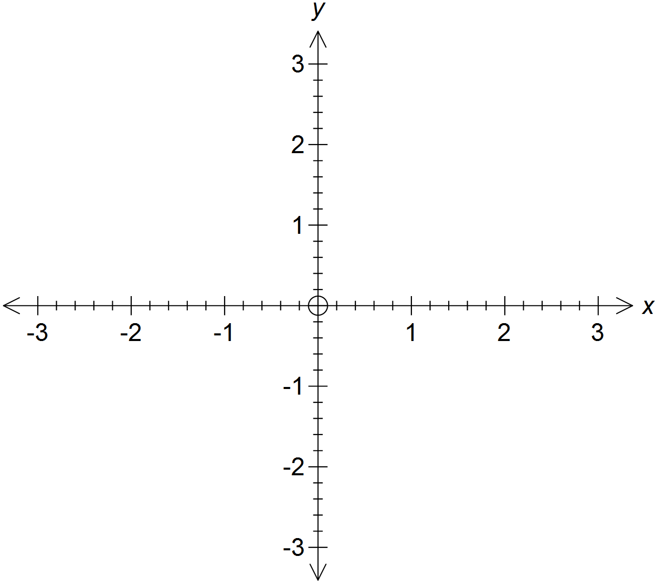

6. [7 marks]

A randomly selected group of 20 Year 12 girls have a mean height of 160 cm with a standard deviation of 1.5 cm.

(a) Use the data to predict the height and standard deviation of all WA Year 12 girls.

(3)

(b) State the 95% confidence limits for the mean height of Year 12 girls in WA. (2)

(c) Explain the difference between 95% confidence limits and 90% confidence limits.

(2)

7. [8 marks]

The number of deaths from Avian (bird) Influenza in Cambodia was reported to the

World Health Organisation (WHO).

Over the years 2010-2015 the number of deaths from Avian Influenza can be

determined by the equation  where  is in years where 

(a) Determine the number of deaths in Cambodia from Avian Influenza in 2012. (2)

(b) (i) Find the rate of increase of cases of Avian Influenza in 2015. (3)

(ii) Is the number of cases increasing or decreasing in 2013? (1)

(c) Sketch the shape of the curve (2)